**Task – Website information gathering**

*Website – warframe.market*

nslookup:

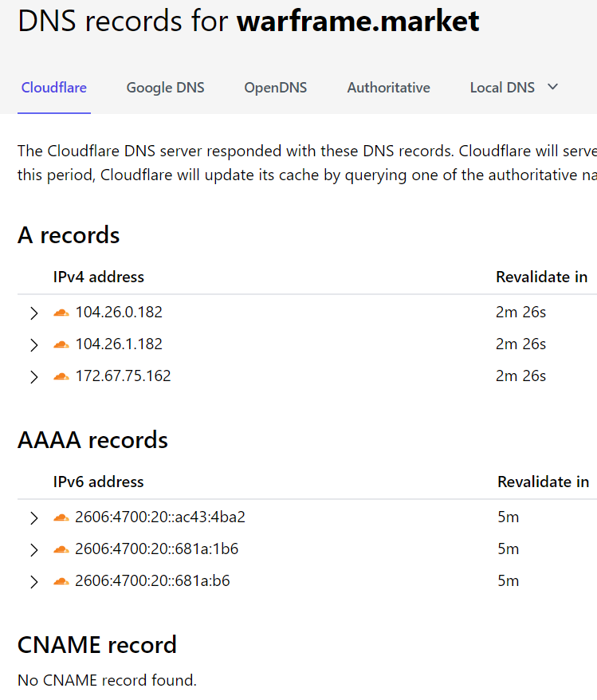

OSNIT:

